KBAI Fall 2024: ARC Project Milestone 1

Anonymous Submission

Abstract

The ARC Prize Challenge presents complex reasoning tasks designed to push the boundaries of AI research, particularly in Artificial General Intelligence (AGI). This paper outlines an approach to the ARC Prize Challenge using Knowledge-Based AI (KBAI) concepts, integrating advanced reasoning techniques and knowledge representation frameworks to tackle multifaceted problems. I describe the design and implementation of my approach, which leverages KBAI principles such as pattern matching, search and planning, and concept learning. Having completed 30 ARC problems for hands-on understanding, I aim to demonstrate the potential of KBAI in achieving high accuracy in solving these tasks. Preliminary results, to be presented in future work, will showcase the effectiveness of my methods. This work contributes not only to the specific goals of the ARC Prize Challenge but also offers broader insights into applying KBAI techniques across AGI tasks.

Introduction

The pursuit of Artificial General Intelligence (AGI) remains one of the most challenging goals in AI research. Since its inception in 2019 by François Chollet, the ARC Prize Challenge has pushed the boundaries of AI capabilities, offering a rigorous test for systems aimed at achieving human-like reasoning. This challenge presents a series of complex tasks requiring innovative approaches that combine reasoning and problem-solving capabilities.

My attempted work draws heavily on Knowledge-Based AI (KBAI), which emphasizes structured knowledge and reasoning processes to simulate human cognition. The ARC Prize Challenge provides a perfect platform to apply and test these methodologies in an environment designed to reward robust solutions to highly complex problems.

In this paper, I describe my system, which utilizes advanced knowledge representation, efficient reasoning algorithms, and adaptive problem-solving strategies. By integrating KBAI techniques such as pattern matching and concept learning, I aim to build a system capable of solving a few ARC tasks with high accuracy. Furthermore, I seek to demonstrate how these KBAI methods can contribute to AGI development by providing both practical insights and theoretical advancements.

To start off with a few examples and types of ARC problems to better help understand the solutions, below is a very simple demonstration of the task that is ARC prize challenge and what I am aiming to solve. On the left I have an image with 3 yellow filled squares, the task is to create the same image in a bigger grid with squares filled out in the places that the first image had and with the same pattern.

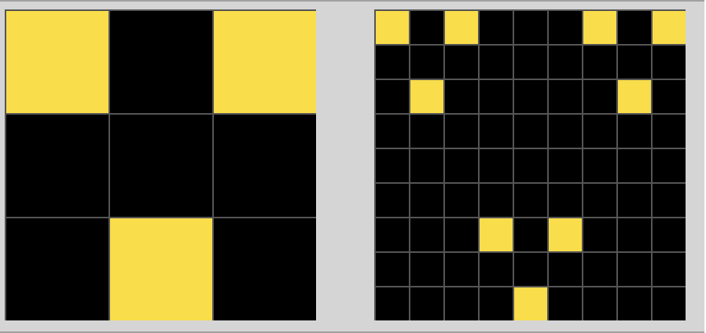

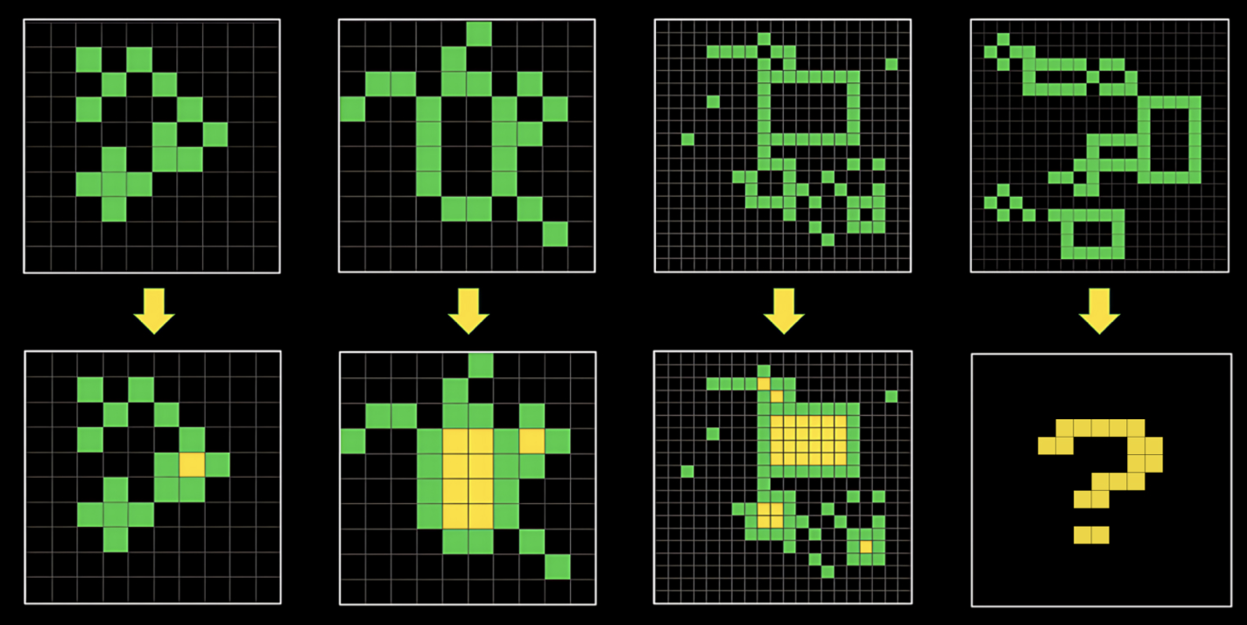

Another example is taken from the arc prize website which shows comprehensive illustrations, and I can see that this is a different example than the one I visited which was a mere match and copy pattern algorithm. This one focusses on finding out the enclosed blank boxes inside the green structures and then filling them out with the color yellow. This can take a human a few seconds to understand so I can image how difficult it can be to implement an approach for a machine implementation.

The next example set is flipping the color of the shown grid. The colors in arc prize training dataset is shown as numerals from 0 – 9 where each number is designed a color. The methodology that can be used here to solve this challenge might be to flip the color numbers and replace them with a different color.

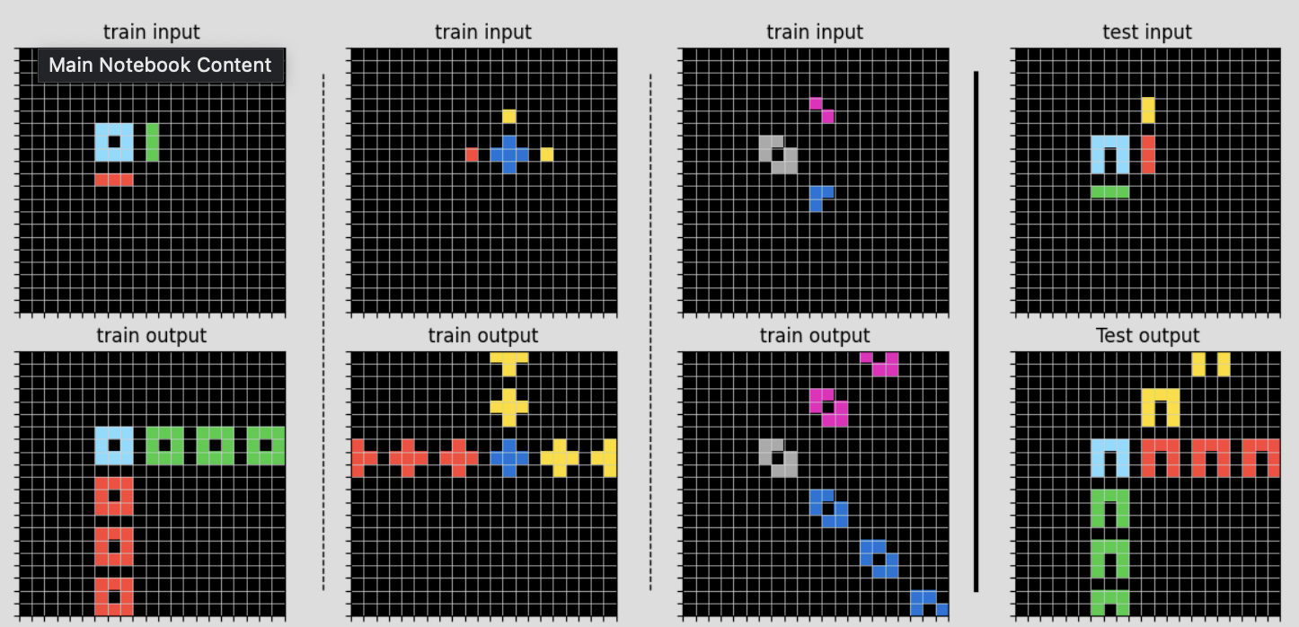The last set of examples is a difficult one, in this test set, as you can see in the first one, a blue square is present with green and red bars, the process one needs to follow is copy the pattern of the blue square and starting from the green bar, repeat the pattern and same thing for the red bar. As we can see, there are various types of problems, and it can be difficult to come up with one solution fits all which is why ARC is a very famous problem in KBAI which can be considered an ultimate test of intelligence.

**Related Work**

Knowledge-Based AI has evolved significantly, with research increasingly focusing on integrating sophisticated reasoning techniques. These include probabilistic reasoning, cognitive modelling, and more recently, neural-symbolic integration and hybrid AI systems, which combine machine learning with symbolic reasoning. The ARC Prize Challenge builds on these foundational methods but extends them by introducing tasks that require diverse reasoning strategies. While traditional KBAI approaches have focused on domain-specific knowledge and rule-based systems, the ARC tasks demand a more adaptive and generalized approach to problem-solving. Recent research has explored neural-symbolic computing, where machine learning is combined with symbolic reasoning [1], and hybrid AI systems that enhance performance by leveraging the strengths of both symbolic AI and data-driven techniques [2]. My approach contributes to this evolving body of work by applying KBAI principles in a tailored manner for the ARC Prize Challenge. I compare my method with other models, highlighting how my focus on structured knowledge and reasoning overcomes certain limitations found in purely data-driven approaches.

A direct comparison of my approach with existing models such as **GPAR**, **DPS**, and **Active Inference** reveals several distinctions:

* **Limitations of Current KBAI Models**: Traditional KBAI methods often struggle with tasks requiring generalization from limited examples. My approach overcomes this by focusing on structured knowledge and reasoning, allowing for more adaptive and robust solutions.
* **Strengths of Hybrid AI Models**: While hybrid AI systems have shown success in integrating machine learning with symbolic reasoning, they sometimes lack the flexibility needed to solve tasks with minimal data. There are various studies which check the Large Language Models for their accuracy levels in solving the ARC challenges, as presented in the class as well, the accuracy levels were not above 50% for most leading LLMs which is surprising. As comprehensively experimented in the study by J. C. Min Tan and M. Motani et al 2024, a recent one, the authors experiment with a lot of different prompt engineering techniques like zero-shot, few-shot, context-grounded prompting to explore the comfort levels of LLMs against the various ARC challenges. Even their novel approach could not reach a success rate >45%.

**Methodology**

The approach discussed to the ARC Prize Challenge is grounded in Knowledge-Based AI (KBAI) principles, which focus on using structured knowledge and reasoning to simulate human cognitive processes. To tackle ARC tasks, I integrate key KBAI methodologies including pattern matching and unification, search and planning, and concept learning. These methods allow us to model how humans might solve problems by recognizing patterns, searching for solutions, and learning from new experiences. Although, in the codebase implemented I was not able to successfully implement all the methodologies for all the test cases but I was able to successfully solve the smaller problems that were 2x2 matrices.

So, for Milestone 2 of the ARC Prize Challenge, my main objective is to refine and detail the Knowledge-Based AI (KBAI) methodologies that will be applied to solve ARC tasks. This includes a theoretical framework and approach grounded in KBAI principles and initial experiments to test their viability.

**Theoretical Framework & Approach (to be implemented)**

My approach will plan to leverage several KBAI techniques to address the complex reasoning tasks of the ARC Prize Challenge. These might include:

1. A screenshot of a computer game

   Description automatically generated**Pattern Matching and Unification**: I plan to implement pattern-matching algorithms that detects repeating structures or sequences in the ARC grids, as we saw in the examples discussed in the introduction section. Unification techniques will be used to generalize from specific instances to broader rules, which can then be applied across different ARC tasks. By identifying structural patterns such as symmetry, repetition, or geometric configurations, I plan to create a system that will infer the correct transformations to match the desired outputs. Something similar was accomplished in the Homework 2 and when I tried that code to check against the input_grid from the test dataset and output_grid from the solution dataset, the runtime was well over 30 minutes which was not good enough. Optimizing the arcpuzzle() class from homework2 can also be considered a future work and a viable comparative approach where after applying several transformations we can check if the input is getting near to the output state, if yes, we can just return the answer. Unification is a process used in logic and AI to determine if two expressions can be made identical by substituting variables with constants or other expressions. This technique allows for generalizing problem-solving strategies from specific instances, enabling systems to apply learned rules to new, unseen problems. Simple arc challenges like the below can be considered as solvable using pattern matching and unification. We learn the pattern from 2x2 matrix and create 9 copies of it, 6 of which are the same orientation and the remaining 3 are mirror images of one another, after this, all the grids can be unified to output the expected output. The representation in pattern matching for the first test case can be something like this - shape(?x, ?color1, (0,0)), shape(?y, ?color2, (0,1)), for the given input we know that - shape(square, blue, (0,0)), shape(square, pink, (0,1)) so we can deduce that ?x, ?y -> square and ?color1 -> blue and ?color2 -> pink, these representations can help us with the goal state.

1. **Knowledge Representation**: The framework can utilize frames and semantic networks to structure and organize knowledge about the objects and relationships present in the ARC grids. Frames might be useful to capture attributes such as color, position, and shape, while semantic networks can represent how different elements in the grids relate to each other. This structured representation will facilitate reasoning by providing the system with a well-organized base of facts and relations to work from. Although these concepts do not aid in coming up with the solution, they help in creating elaborate representations which might guide one to the goal state.
2. **Search and Planning Mechanisms**: I plan to use rule-based reasoning systems to attempt to solve arc prize challenge. Rule-based systems will apply predefined rules to make logical deductions about how to modify the grid. On the other hand, Case-based reasoning might allow the system to compare new tasks with previously solved ones, drawing on past solutions to solve similar problems. Search algorithms like depth-first search (DFS) and breadth-first search (BFS) will be incorporated to explore possible grid modifications and select the best sequence of transformations. Other machine learning models can be trained to implement a system based on case-based reasoning too wherein it can keep a track of how it reached the goal state and a similar approach can be applied to a new test problem. Studies and Kaggle solutions using CNNs, RNNs have been implemented and a complex problem like the below has been attempted. [4]
3. 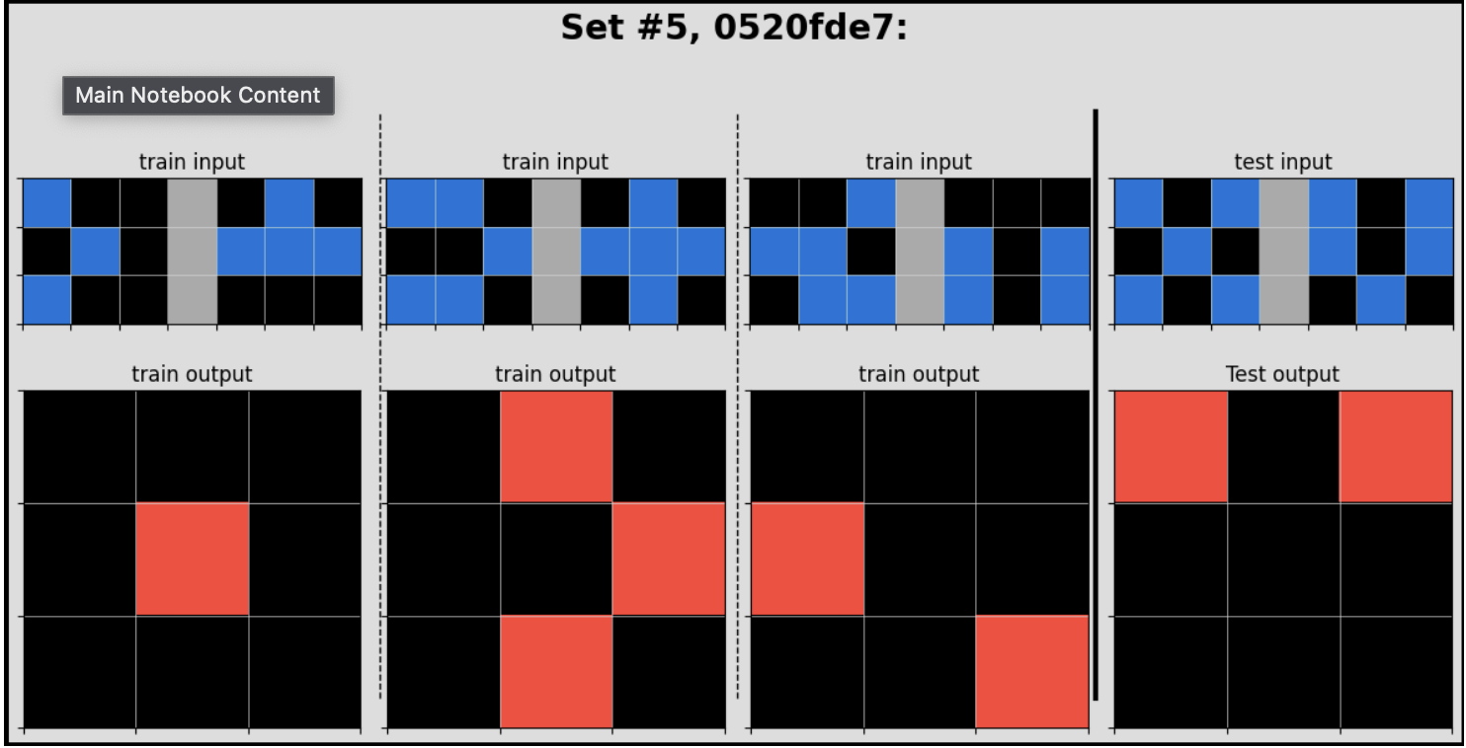**Concept Learning & Logic**: To improve generalization, one can implement a system that will use concept learning to identify and apply abstract rules learned from solved ARC tasks. This will allow the system to infer high-level patterns from few examples, making it better suited to solving novel ARC problems. It might be a far reach but one can implement Abductive inferences to solve an arc challenge like the below. This is essentially an “AND” operation on the pattern as we can see that in the first test input, both the images have a blue square in the position (1, 1) filled i.e. (0,0)[blue square] from first set AND (0,0)[black square] from set 2 of the first train input have different colours, we can interpret the black square as empty too, so the train output does not have a filled square in the position (0,0) and so on.

**Preliminary work**

I have conducted preliminary experiments using the train and test public arc datasets. To test the system, I submitted a basic implementation to the ARC Prize Challenge on Gradescope.

* **Initial Submission**: The system was able to complete simpler pattern-matching tasks involving straightforward transformations, such as replicating patterns across different grid sizes. However, it struggled with more complex tasks that required advanced reasoning, such as filling enclosed areas or handling multiple overlapping transformations.
* **Results and Observations**: The initial submission yielded a score of 1.0/400, which highlighted both the limitations of my current approach. Specifically, pattern detection and replication performed well, but the system needs further refinement in handling tasks that involve more nuanced reasoning about the relationships between objects. I observed that while rule-based systems worked for simpler problems, they lacked the flexibility needed for tasks requiring generalization from minimal data.

Conclusion and Future Work

This milestone outlines my approach to tackling the ARC Prize Challenge using KBAI techniques. By leveraging advanced reasoning methods and structured knowledge, I aim to contribute to the ongoing discourse on AGI and AI research. Future work will focus on presenting refined approach, a higher score, and further exploring the integration of KBAI with machine learning methods to create even more robust AI systems capable of solving highly complex reasoning tasks.

References

1. Garcez, A. d., Gori, M., Lamb, L. C., Serafini, L., Spranger, M., & Tran, S. N. (2019). Neural-Symbolic Computing: An Effective Methodology for Principled Integration of Machine Learning and Reasoning. *arxiv:1905.06088*.
2. Chollet, F. et al. (2019). On the Measure of Intelligence. *arxiv:1911.01547*.
3. J. C. Min Tan and M. Motani, "LLMs as a System of Multiple Expert Agents: An Approach to Solve the Abstraction and Reasoning Corpus (ARC) Challenge," *2024 IEEE Conference on Artificial Intelligence (CAI)*, Singapore, Singapore, 2024, pp. 782-787, doi: 10.1109/CAI59869.2024.00149.
4. Kaggle submission - <https://www.kaggle.com/code/minseo14/arc-with-rnn>